- Video link :- https://www.linkedin.com/posts/jadige-umarani-931322351_oasisinfobyte-oibsip-python-activity-7470503802991755264-mFx2?utm_source=share&utm_medium=member_desktop&rcm=ACoAAFfKaLUB4yLqOJiaTmhoG6It2uwPR_lSIKo
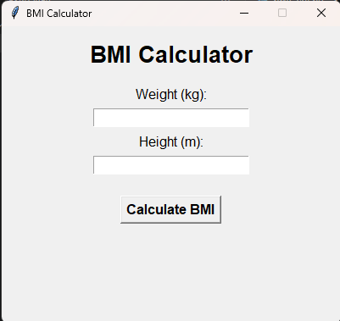
Basic page
Output